Hialeah Middle School
Summer Reading Assignment 2022
- Select one Grade 6-8 book of your choice. If you need a book, books are available for FREE in the Hialeah Middle School main office.
- After reading the book, complete three squares in a row (horizontal, vertical, or diagonal) to make tic-tac-toe. All assignments will be submitted to your Language Arts teacher either online or in person when school opens in August.
- Each Assignment is worth 1 grade, so this assignment is worth 3 Grades.
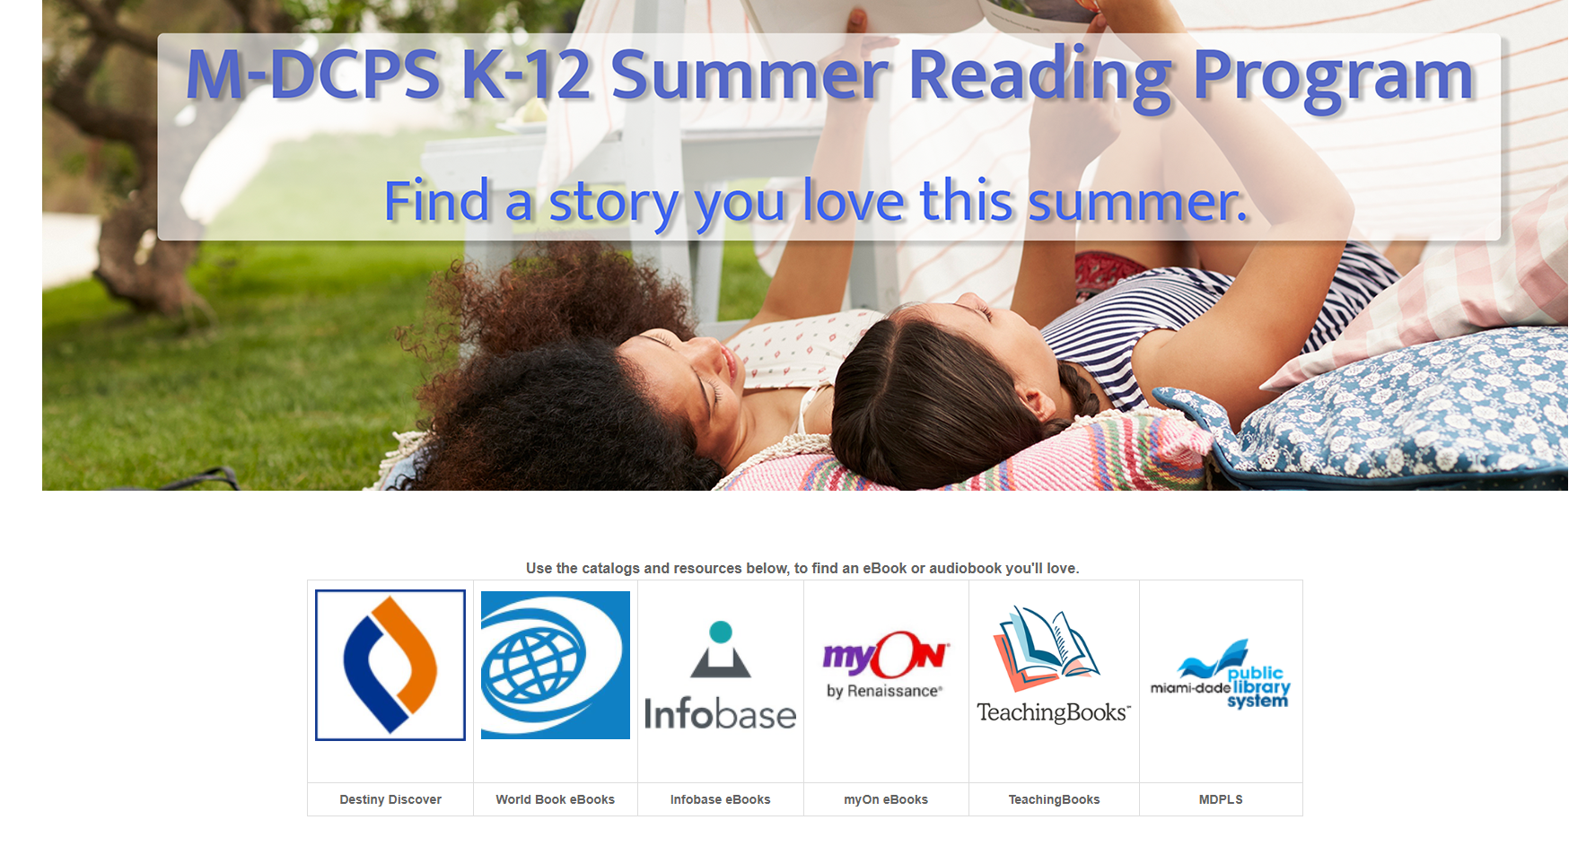
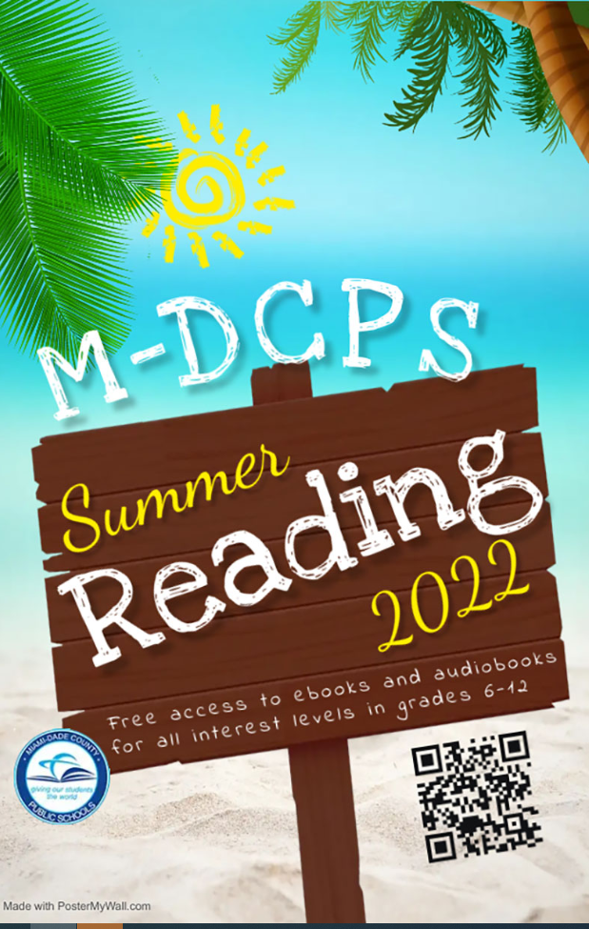
SUMMER READING: TIC TAC TOE
Directions: Read a Grade 6-8 level book of your choice (Free books are available in the Hialeah Middle School office) and complete three squares in a row (horizontal, vertical, or diagonal) to make a tic-tac-toe. All assignments must be submitted online or in person to your Language Arts teacher when school opens next year.
Find ten vocabulary words in the book that you think are most challenging and list them with definitions. Write an example sentence for each word (not the sentence from the book). | Drama  Write a short skit about a major event in the book you read. Explain Why you chose this event to act out. Perform and record the skit using your phone/device. You can invite your family and friends to help you. Make sure the video link can be shared with your teacher. | Character Descriptions  Choose 2 characters from your  book and create a Venn Diagram Chart Comparing and Contrasting the two characters, Find at least 5 difference and 5 Similarities.
Literary Collage  Create a Picture /Word Collage of 15 items that represents your book. Write a paragraph of 5-6 sentences explaining why you selected the words/ pictures about your book. | Write a 1-page letter to your teacher  and tell him/her about the novel  you read! Make sure you tell  him/her about the main characters,  problem, solution, and if you  enjoyed the book! | Theme Song  Find a song that relates to the theme of your book. Write the Title, Singer and 5-6 sentences explain how this song matches the theme in the story.
Book Poster  Create a Poster that will encourage other students to read this book. Include a Picture, Brief Summary (5-6 sentences) , and add pictures that will capture the reader’s attention. | Create a Crossword  Find at least 10 difficult or interesting words you found in your book. Create a crossword or word find using these words at  http://puzzlemaker.discoveryeducation.com/WordSearchSetupForm.asp | Poetry  Write your own 15-line poem that relates to the events, theme, or characters of your story. You must include two examples of figurative language in your poem.

